**What is Git Lab:**

A web-based DevOps lifecycle tool (Building, Testing, Deploy).

**Provide Feature Like**

--CI/CD pipeline features

--Collaboration on code and project management.

--Monitoring and Security tool

**Diff /w GitLab and GitHub**

You can run GitLab on your own self hosted Server, but Git Hub Can’t.

Login to gitlab.com and create an account,

**Create Group**

**Create Project in this group.**

**Import from GitHub project in GitLab Project.**

**Now My GitHub repo is in GitLab**

**Environment Variables: -**

**Setting----CICD---Variable----Add variable**

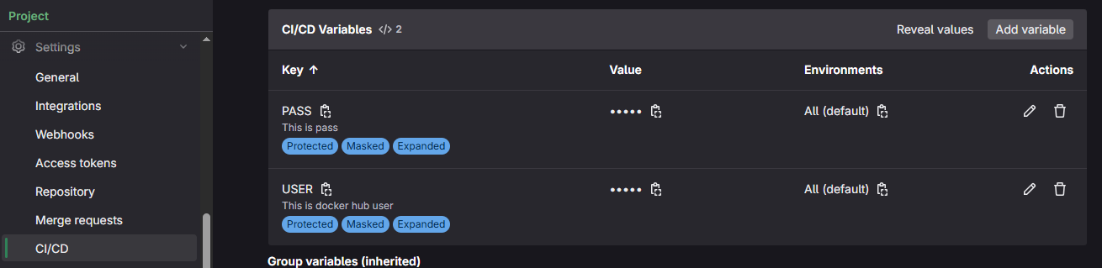

**Create a pipeline with Pre-defined Variable, User-Defined Variable and Setup Artifacts to store logs: -**

